# [**Law & Order 10 Ways Olivia Benson From SVU Has Changed Since Season 1**](https://screenrant.com/law-order-svu-olivia-benson-changes-since-season-1/amp/?__twitter_impression=true&s=09)

Olivia Benson was an awesome character in Law & Order: SVU, and has gone through some major changes since season one.

[**BY GABRIELA SILVA**](https://screenrant.com/author/g_silva/)SEP 13, 2020

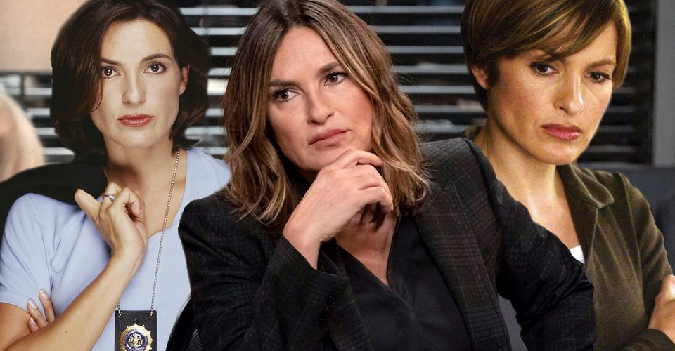

Olivia Benson, played by actress Mariska Hargitay, has been the longest-running original character on the popular procedural crime show, [*Law & Order: Special Victims Unit*](https://screenrant.com/tag/law-and-ordersvu/)*.* Audiences have watched Benson for the past 22 seasons grow as an individual and as a strong character on the show.

**RELATED:**[**Law & Order: SVU – 10 Facts You Didn't Know About Olivia Benson**](https://screenrant.com/law-order-svu-olivia-benson-surprising-facts/)

Benson is a pro when it comes to solving special victims cases and has morphed into much more than just a detective. She has gone through her fair share of trials and tribulations since her first appearance in 1999. From a rookie detective to being the leader of her squad, Benson is the heart of the show. Throughout her time, Benson has progressed beyond her original storyline on the show.

## **10Has Comes To Terms With Elliot's Departure**



Many fans of the show adored the partnership between Benson and Elliot Stabler. They were opposites to one another yet their teamwork made for good crime-solving. At one point in the show, [Elliot's character was written off](https://screenrant.com/law-order-svu-times-fans-loved-hated-elliot-stabler/) and left Benson without a partner.

Throughout the rest of the seasons, audiences see Benson's disdain towards his leave. Especially when he gives no real explanation. Along the way, Benson comes to terms with it and even on occasion still references yot his past demeanor as a detective and partner.

## **9Becomes More Invested And Emotional**

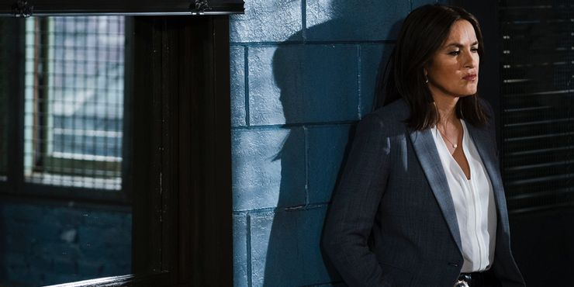

At the beginning of Benson's time as SVU, she held back some of her emotions in order to get the job done. As the show progressed, as well as her storyline, Benson becomes more involved emotionally with every case. It might be due to the years on the job or her personal experience.

Benson's [emotions during cases allowed for a more dynamic storyline](https://screenrant.com/law-order-svu-aspects-accurate-fictional/) that expressed the seriousness of the crime. There are a number of occasions where viewers can see Benson on the verge of tears in frustration.

## **8Believes The Victims More**

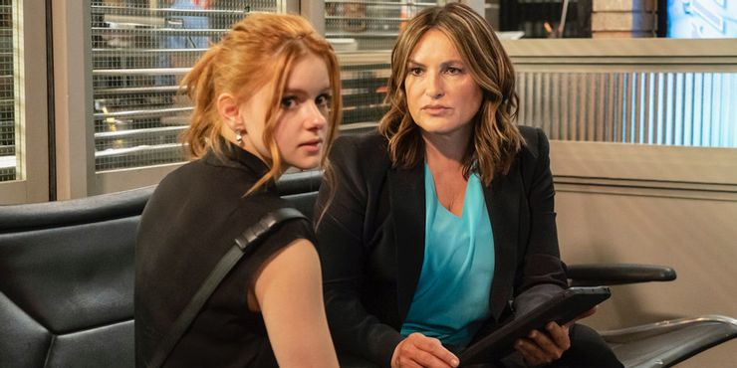

After years on the force and dealing with [heinous special victim crimes](https://screenrant.com/law-order-worst-crimes-committed-whole-franchise/), Benson has seen a variety of victims and witnesses. Int he beginning, Benson was a bit more reserved at times to put her full trust in the victim. She sometimes would wait until there was concrete evidence or a lead.

Benson has changed in this regard as she puts her faith and trust in the victim first and foremost. The adopted motto of a detective having to always believe the victim. This can be seen in "Criminal Stories" when the victim wasn't seen as reliable due to her changing story. The same when a victim doesn't recall her assault and there's no viable drug evidence.

## **7More Aggressive Interview Tactics**

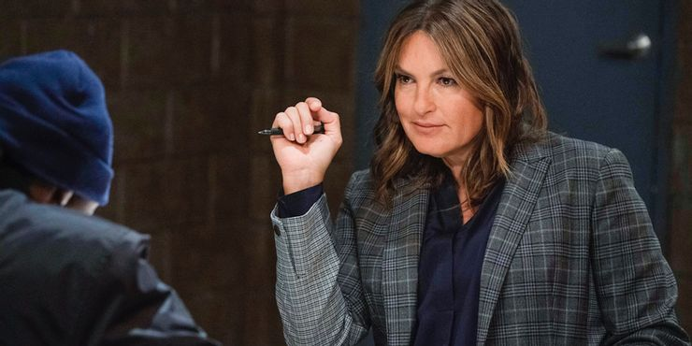

Benson might have learned a thing or two when partnered with Elliot. Over the curse of the show, Benson has taken the reigns when it comes to interviewing perps that get under her skin. She's not afraid of getting close and personal to elicit a response. She's even [roughed up a few in the interview room.](https://screenrant.com/things-movies-tv-shows-get-wrong-about-cops/)

**RELATED:** [**Law & Order: SVU: 10 Episodes Based On Real-Life Cases**](https://screenrant.com/law-order-svu-episodes-based-on-real-life-cases/)

Her new tactics also translate outside the squad room with possible suspects. Benson has taken charge over the years and doesn't take light to a perps threat. In "Unintended Consequences" in season 19, Benson even gets close to a perp and gives him a warning that'll she lay her hands on him if he calls her a "ho" again.

## **6Isn't Afraid Of The Higher Ups**

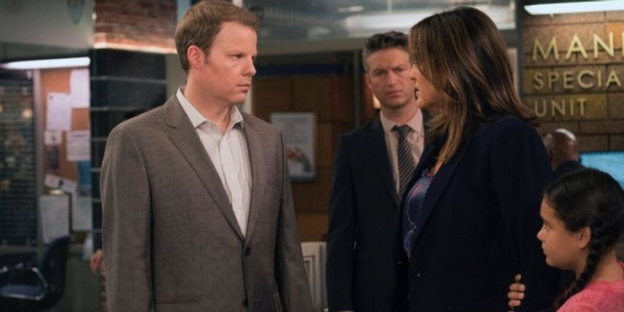

There's no question that Benson has always stood her ground, but it has become even more prevalent as the show has gone on. This is especially true when it comes to perps who think they're above the law or IAB. IAB has for a long time been a rival to the squad but Benson no longer takes them as a threat.

At times she even welcomes them to try and pull something knowing they're in the wrong. In one episode, Benson even puts her job in jeopardy to expose a perp to a local reporter before the FBI arrives. At one point, she helps a victim get away from her attacker even if its against protocol. She even arrests an immigration worker for kidnapping.

## **5She's A Mother**

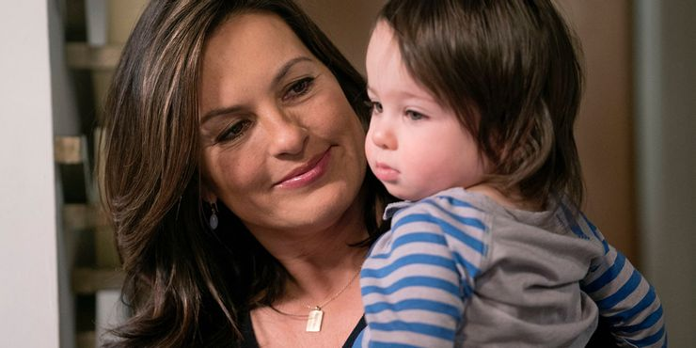

Benson has become a mom to a young boy named Noah in the last couple of seasons of the show. Noah was the baby of a victim from a previous storyline, who Benson feels a strong connection to and decides to adopt him. This was a major shift in her story when in "Inconceivable" Benson expressed her desire to [have a family and be a parent.](https://screenrant.com/law-order-svu-when-elliot-bad-father-husband/)

In the end, she revealed to Elliot that she had looked into adoption but they rejected her for not having a suitable life to be a parent. Now as a mother to a young boy, Benson sees her career differently and her assessment of cases more emotionally. Noah's inclusion allows audiences to see her softer side away from a diligent detective.

## **4She Was Close To Love**

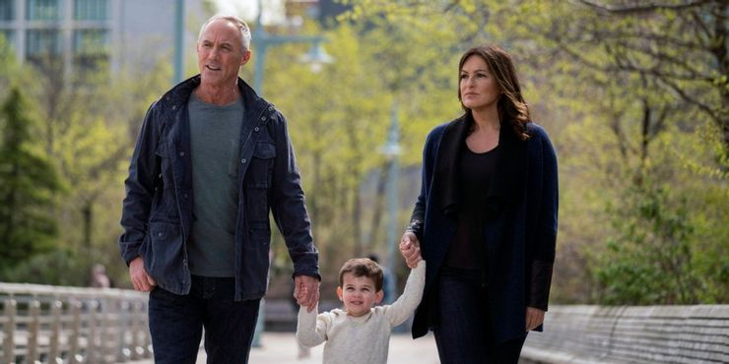

When the show first aired, Benson's love life wasn't put at the forefront. There were dates here and there and small inklings of love. In recent seasons, Benson's romantic interests have blossomed to a point being serious relationships. She has become more open to the idea of having a life partner.

Her two major relationships were with Brian Cassidy who once was part of SVU at the beginning of the show. The second relationship that showed promise was with IAB Captain Ed Tucker. This was the most serious one seeing as Benson actually thought about sticking in the long run. This relationship ended due to the fact that Benson thought about her son first and felt that she wasn't ready to stop her career.

## **3No Longer Suffers From Her Family Past**

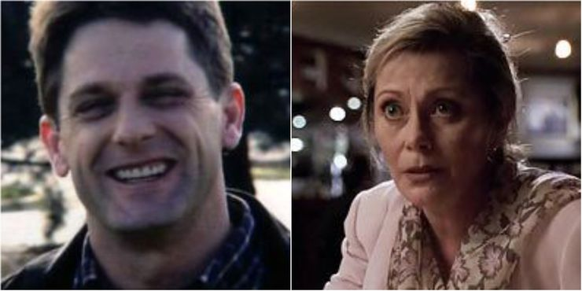

When audiences are first introduced to Benson, they are aware that she didn't have the best home life. Her mother was an alcoholic that didn't take care of her and died an accidental death. It's later revealed that Benson is the result of her mother's rape and the reason for resenting her daughter.

RELATED: [Law and Order SVU: 10 Hidden Details About The Main Characters Everyone Missed](https://screenrant.com/law-order-svu-hidden-character-details/)

As the show progressed, this plagues Benson and her outlook on herself. Especially when she discovers who her father was. She often questioned if because of her father she would turn out like him or her mother and had her questioning her future as a mother. Benson has since moved past her family ordeal and uses it as a source of strength in her job. She has come to terms with the fact that she has grown to be a better person than her parents.

## **2Suffers From PTSD**

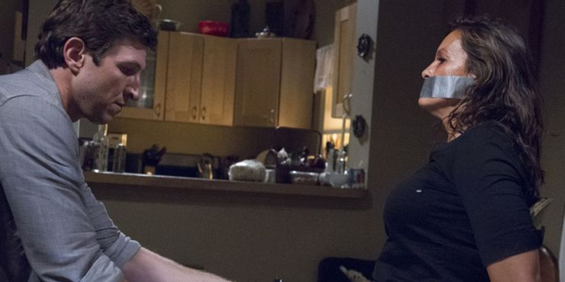

The major shift and cataclysm to Benson's character storyline was [the involvement of William Lewis.](https://screenrant.com/law-order-special-victims-unit-cop-victims/) William Lewis was perp wanted for multiple assaults and murders who ends up becoming infatuated with Benson. He soon kidnaps her with an intent to harm her.

Lewis was Benson's worst enemy that effectively damaged her emotionally and mentally. She ends up suffering from PTSD from her ordeal and has a hard time coping. At the request of the squad, she seeks counseling that changes Benons's outlook on victims and her assessment of her career.

## **1She Rises To The Ranks Of Captain**

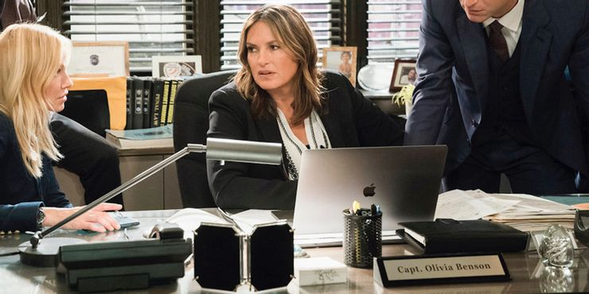

It would be odd if Benson hasn't leveled up in position over the 22 seasons on the show. Benson not only becomes a sergeant but later on rises to the ranks to become the Captain of SVU. [She is notably one of their best](https://screenrant.com/law-order-original-svu-series-best/), maybe even better than Cragen due to her ability to empathize with victims.

Her new role as Captain has allowed Benson to prove herself even more as a qualified leader who would do whatever it takes to catch the perp and seek justice.